**1.INTRODUCTION**

This Software project is aimed at automation of Ticket booking. Objective of the project is to develop customize software package for Ticket booking.

In our daily life we have to book ticket for Bus, movies, Flight and cricket match or foot boll match. When we do this task manually then it becomes very hard to manage the ticket booking. So are developing this system to manage booking of ticket automatically. In this [bus and railway ticket booking](https://sites.google.com/site/downloadmebad/system/errors/NodeNotFound?suri=wuid://defaultdomain/downloadmebad/gx:2eb502589d310726&attredirects=0&d=1) project we develop the system that can help the user to book their ticket online and offline manner. In this project we take care of every service related to travelling and online ticket booking. When you start your traveling tour you have to book ticket so we help you from the starting point to the end. we help you in booking your traveling ticket.  [bus or railway ticket booking system in php](https://docs.google.com/viewer?a=v&pid=sites&srcid=ZGVmYXVsdGRvbWFpbnxkb3dubG9hZG1lYmFkfGd4OjU3YWJkNmQ2N2YxYjQxZQ) then when you reached your destination we help you with booking details. you can also book more than one ticket from this project system.

This is a **PHP Project** entitled **Railway Reservation System**. It is a web-based application that provides an online platform for railway or train station passengers or possible passengers to explore their schedules and reserve a seat. This application does support any payment API and was developed only for educational purposes to give an idea to the IT/CS students and self-taught programmers about how to develop a web application like this. The application has a pleasant user interface using Bootstrap Framework and AdminLTE Framework. It is easy to use or user-friendly.

A simple bus and train reservation system is written in PHP. The project has both an admin and a user side. The administrator has access to the bus and train schedules, as well as the tickets that have been purchased.  
Users are customers who wish to find and book a bus or train ticket that is appropriate for them. To make a reservation, a user must first log in. If he or she has not yet registered, they might do so first before logging in. A user can look for available tickets for a specific city pair and order tickets in their preferred class. This is a relatively basic project that saves both the consumer and the travel operator time and money, therefore making bus and train travel more customer-centric.

PHP, CSS, JavaScript, and bootstrap are used to create this reservation system. When it comes to the application’s features, it includes both an admin and a user part. The user can log in and buy tickets, while the administrators can see all of the users’ reservations and manage the bus and rail schedules. This project’s design is simple enough that the user will have no difficulty working on it.

**2.ABSTRACT**

The **Simple Railway Reservation System** has 2 modules which are the **Management Side** and **Public Side**. The **Management Module** is the side of the system where the management can manage the system information, schedules, and reservations. On this side, the admin user can update also the content pages that are shown on the website such as the 'About' and 'Contact' Information Contents. The **Public Module** serves as the website that can be accessed by visitors or possible passengers. The visitors can read the information about the station, list the schedules, and reserve their seats on their selected schedule. The passenger can submit multiple seat reservations at once.

The researchers conducted the capstone project entitled “Bus or Train Booking System” to help commuters reserve a seat on the train or bus via the this php application, this will also help the management by promoting innovation to their customers. Train or Bus Booking System was developed in PHP, MySQL and Bootstrap using the Rapid Application Development software development life cycle. The said project had undergone several testing and evaluation using standardized set of questionnaires. The evaluation was rated by the end-users (commuters and bus operator management) and IT experts, results showed that by using the said it system, it would make the transactions easier, faster and convenient to both the commuters and management. In the findings of the study, researchers conclude that the “Train and Bus Booking System” meets the requirements of the end-users and it is highly recommended for implementation as an alternative way of reserving a seat on a train and bus.

**3.OBJECTIVES**

The main objective of the PHP Project on Railway Ticket Reservation system is to manage the details of Trains, Fare, Stations, Timetable, Booking. It manages all the information about Trains, Customers, Booking, Trains. The project is totally built at administrative end and thus only the administrator is guaranteed the access, The purpose of the project is to build an application program to reduce the manual work for managing the Trains, Fare, Customers, Stations. It tracks all the details about the Stations, Timetable, Booking.

It manage the details of Ticket Booking, Sales, Customer,Bus, Operators. It manages all the information about Ticket Booking, Booking, Operators, Ticket Booking. The project is totally built at administrative end and thus only the administrator is guaranteed the access. The purpose of the project is to build an application program to reduce the manual work for managing the Ticket Booking, Sales, Booking, Customer. It tracks all the details about the Customer,Bus,Train, Operators.

**4. SYSTEM ANALYSIS**

System analysis is the process of gathering and interpreting facts, diagnosing problem and using the information to recommend improvements on the system. System analysis is a problem solving activity that requires intensive communication between the system user and system developers.

System analysis or study is an important phase of any system development process. The system is studied to the minutest detail and analyzed. The system analyst plays the role of an interrogator and dwells deep into the working of the present system. The system is viewed as a whole and the inputs to the system are identified. The outputs from the organization are traced through the various processing that the inputs phase through in the organization.

A detailed study of these processes must be made by various techniques like Interview, Questionnaires etc. The data collected by these sources must be scrutinized to arrive to a conclusion. The conclusion is an understanding of how the system functions. This system is called the existing system. Now, the existing system is subjected to close study and the problem solver and tries to sort out the difficulties that the enterprise faces. The solution is given as a proposal.

The proposal is then weighted with the existing system analytically and the best one is selected. The proposal is reviewed on user request and suitable changes are made. This loop ends as soon as the user is satisfied with the proposal.

**3.1 EXITING SYSTEM**

The existing system is very complex as every work is done manually. By using the present system, work is done manually. So, each and every work takes much time to complete. Whenever the users needs the information it is very difficult for the users to search for that particular train or bus or source and destination details and the information to be ordered. Every time we should search the records at the shelves. Initially, customers used to book tickets manually by queuing in lines at bus stations or go to travel agents who in turn used to book tickets for them. This was actually a tedious process and was leading to wastage of time.  It also had issues like having incorrect names or other information used to book tickets.

**3.2 PROPOSED SYSTEM**

The present system has obvious problems, inhibiting growth and more usage of man power. The present system which has been proposed is very easy to work .The computerization of the every department in the Ticket booking system will reduce the work that is done manually. The man power is reduced to the maximum extent. The users at the railway registration office are registered within no time, because every time there is no need search for the particular opon in the stations .The details about the trains or bus and users are maintained without any complexity and all the calculations are made automatically by this system there is no need for the calculations. We can eliminate the drawbacks by developing an application which will allow customers to register themselves and book tickets, cancel tickets or postpone or prepone travel dates with feasibility. This actually is a welcome step for customers as they can access the application from anywhere and will also avoid wastage of time that was caused due to the drawbacks in the previous way of booking tickets manually.

**5.DEVELOPMENT PROCESS MODEL:**

When building a web system, it is important to go through a series of predictable steps, a road map that helps you create a timely, high quality result and it is known as process model.

Otherwise system ends up with lots of pits and falls. It is important because it provides stability, control, and organization to an activity that can, if left uncontrolled, become quite chaotic.

Varieties of models are available for web engineering and design. Each represents an attempt to bring order to an inherently chaotic activity; each of the models has been characterized in a way that assists in the control and co-ordination of the real software project.

The selection of process model is depending on the system type. One process might be appropriate for creating software for an aircraft avionics system, while an entirely different process would be indicated for the creation of a web site.

The process model choice is based on the nature of the project and application, the methods and tools to be used, and the controls and deliverables that are required. For this project the waterfall model is selected because of familiarity, small size of project.

The other reasons are, this process provides clear progress, easy management and each tasks are clear here.

Systems are created to solve problems. One can think of the systems approach as an organized way of dealing with a problem. In this dynamic world, the subject System Analysis and Design (SAD) mainly deals with the software development activities.

Defining a System A collection of components that work together to realize some objective forms a system. Basically there are three major components in every system, namely input, processing and output.

8 In a system the different components are connected with each other and they are interdependent.

For example, human body represents a complete natural system. We are also bound by many national systems such as political system, economic system, educational system and so forth.

System Life Cycle System life cycle is an organizational process of developing and maintaining systems. It helps in establishing a system project plan, because it gives overall list of processes and sub-processes required for developing a system. System development life cycle means combination of various activities.

In other words we can say that various activities put together are referred as system development life cycle.

Following are the different phases of software development cycle:

♣ System study

♣ Feasibility study

♣ System analysis

♣ System design

♣ Coding

♣ Testing

♣ Implementation

♣ Maintenance

* 1. **THE WATERFALL MODEL**

The waterfall model is also known as linear sequential or classic life cycle model. It

suggests a systematic, sequential approach to software development that begins at the system

level and progresses through analysis, design, implementation, testing and support.

The advantages of waterfall development are that it allows for departmentalization and control. A schedule can be set with deadlines for each stage of development and a product can proceed through the development process model phases one by one.

Development moves from concept, through design, implementation, testing, installation, troubleshooting, and ends up at operation and maintenance. Each phase of development proceeds in strict order.

Some of the major advantages of the Waterfall Model are as follows −

* Simple and easy to understand and use
* Easy to manage due to the rigidity of the model. Each phase has specific deliverables and a review process.
* Phases are processed and completed one at a time.
* Works well for smaller projects where requirements are very well understood.
* Clearly defined stages.
* Well understood milestones.
* Easy to arrange tasks.
* Process and results are well documented.

The waterfall model shown in the figure below:

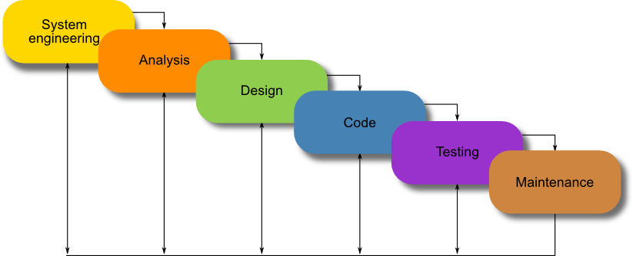

**6.SYSTEM IMPLEMENTATION:**

The platform is the hardware and software combination that the Client/Server runs on. While hardware systems vary widely in features and capabilities, certain common features are needed for the operating system software.

6.1 HARDWARE SPECIFICATIONS

Hardware is a set of physical components, which performs the functions of applying appropriate, predefined instructions. In other words, one can say that electronic and mechanical parts of computer constitute hardware.

**Processors and memory**

The best system to start with is one based on Pentium II with a minimum 32 MB of RAM. Adequate performance requires at least 64 MB of RAM. But for a database server at least 64 to 128 MB of RAM is required.

**Video displays**

Earlier, the IBM-compatible computers had a simple text-only monochrome for the video display. Now, they use the advanced high-resolution color displays. For Client/Server systems one should have VGA or better video display.

In the following table TLA stands for the various types of adapters that can be used with IBM compatible PCs and the standard resolution for each one of them. 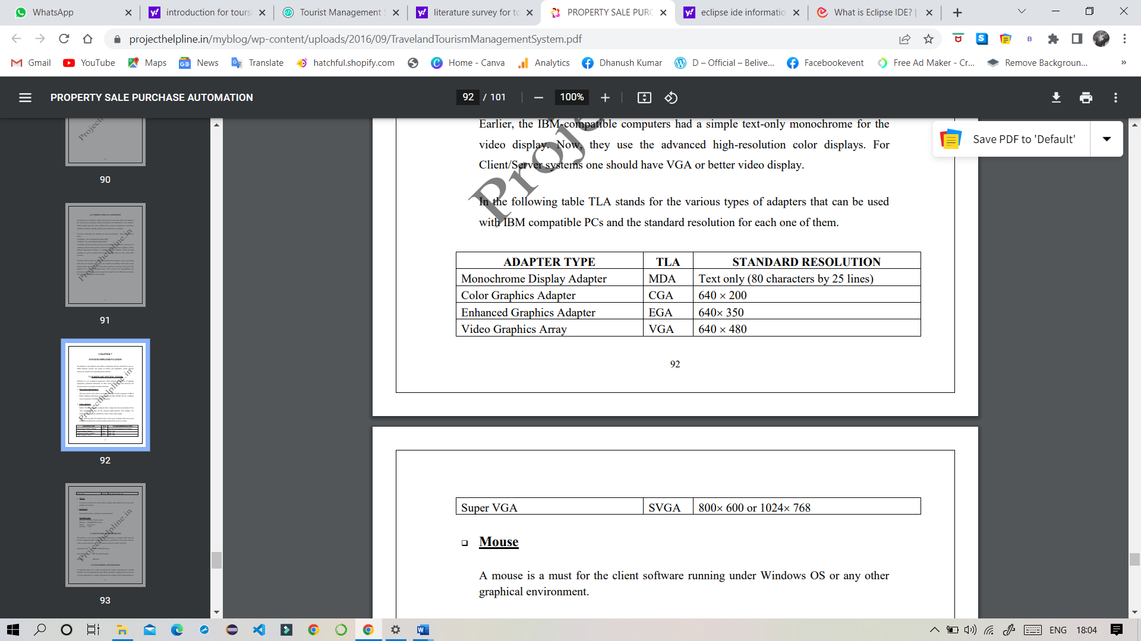

**Mouse:**

A mouse is a must for the client software running under Windows OS or any other graphical environment.

**Keyboard:**

Each client must have a 104 keys extended keyboard.

**SOME OF TOOLS ARE USED TO IMPLEMENT THE PROJECT:**

* 1. Xampp Server
  2. MySQL – DataBase
  3. Eclipse IDE

**XAMPP SERVER:**

XAMPP is a cross-platform web server that is free and open-source. XAMPP is a short form for Cross-Platform, Apache, MySQL, PHP, and Perl. XAMPP is a popular cross-platform web server that allows programmers to write and test their code on a local webserver. It was created by Apache Friends, and the public can revise or modify its native source code. It includes MariaDB, Apache HTTP Server, and interpreters for PHP and Perl, among other computer languages. Because of XAMPP’s simplicity of deployment, a developer can quickly and easily install a WAMP or LAMP stack on an operating system, with the added benefit that common add-in apps like WordPress and Joomla can also be loaded.

### Need for a XAMPP

* XAMPP is simply a local host or server.
* This local server runs on your personal computer, whether it’s a desktop or a laptop.
* It is used to test clients or websites before publishing them to a remote web server.
* On a local computer, the XAMPP server software provides a suitable environment for testing MYSQL, PHP, Apache, and Perl projects. Because most real-world web server deployments share the same components as XAMPP, moving from a local test server to a live server is straightforward.

**MYSQL DATABASE:**

MySQL is a database management system that is used to maintain relational databases. It is an open-source software backed by Oracle Corporation. This was originally founded by a Swedish company called MYSQL AB which was later acquired by sun microsystems and finally is with Oracle Corporation. As it is an open-source database system, the source code can be modified according to our needs. It also offers premium services if a commercial license is purchased from Oracle Corporation. MySQL is a scalable, fast, and reliable database management system which can run on any platform like Windows, Unix, Linux, etc., and can be installed on the desktop or any server machine.

It is also very to master compared to other database management systems existing in the market like Microsoft SQL Server, [Oracle Database](https://www.educba.com/what-is-oracle-database/), etc. MySQL is most suitable for web applications. MySQL is an essential component of the LAMP stack, which includes Linux, Apache, MySQL, and PHP. LAMP is a platform for web development using Linux as the operating system, the webserver of apache, relational database management system of mysql and object-oriented scripting of PHP. There are many top websites using mysql. Apart from this, there are numerous corporations using mysql as their relational database management system. Few examples include Youtube, Facebook, Twitter, etc. MySQL works on a client-server model, the MySQL server being the core handling all commands.

**ECLIPSE IDE:**

The Eclipse is defined as platform for developing the computer-based applications using various programming language like JAVA, Python, C/C++, Ruby and many more. The Eclipse is IDE (Integrated development kit) and mainly JAVA based programming is done in this platform. There are several plug-ins and other additional plug-ins can be installed in the platform. The advanced client applications can be developed. The JDT is used for doing the programming in Eclipse IDE.

### Importance of Eclipse IDE

Given below are the several importance factors that are mentioned:

#### 1. Code insight or code competition

For any type of IDE platform, the identifying of function and keywords for any particular programming language is always a crucial part. In the Eclipse IDE the plugins are available for every programming type language so that it is capable of identifying the keywords very easily and helps to develop the applications in this platform.

#### 2. Provide workspace

It provides the workspace in which user can bundle all the projects in single workspace. In that single workspace the source files, artifacts, images all can be stored in the workspace. The user has the complete functionality to select the name of workspace and manage the projects in single workspace.

#### 3. Provide editors and views

It provides the editors and views for navigating in between IDE and change the content. These different views are known as perspective in eclipse IDE. For every particular group of data separate view is provided to user. Every view has its own hierarchical data and when user click on other view the data hierarchy is changed and get displayed of that particular view. For e.g. the project explorer view displays the list of all projects on which user is currently working. The user can access the files and projects in the project explorer view.

**7.MODULES OF TICKET BOOKING MANAGEMENT SYSTEM**

This section attempts to describe each module of the project in brief, and the detailed description of each of these modules is spread throughout this document.

The Ticket Booking Management System project has been divided into three modules. They are

1. User Register

In the User register module, if there is new user, If they need to book train or bus, they should need Registered Account according to that reason user need to must have registered account before accessing any information from the official booking web portal, so they can create them account by using this User Registration module, this module ask the personal details of the new users for new accounts.

1. User Sign In

After successfully creation of new account, user need to sign in to the portal. User Sign In portal provides five different modules, They are.

* 1. Home
  2. Train Ticket
  3. Bus Ticket
  4. User Bookings
  5. Train Schedule 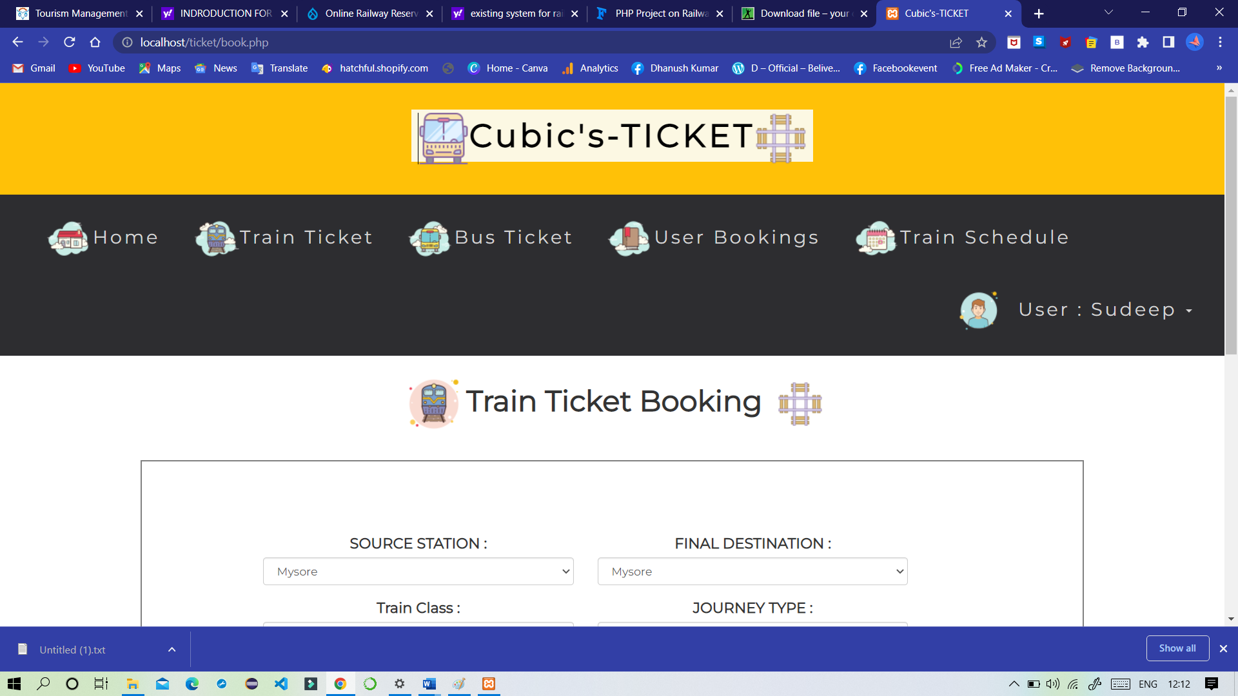

1. Admin Sign In

Here, In Admin Panel, Admin can manage all the user information and the train and bus bookings. It had two different modules in the admin section, they are.

* 1. View Train Bookings
  2. View Bus Bookings

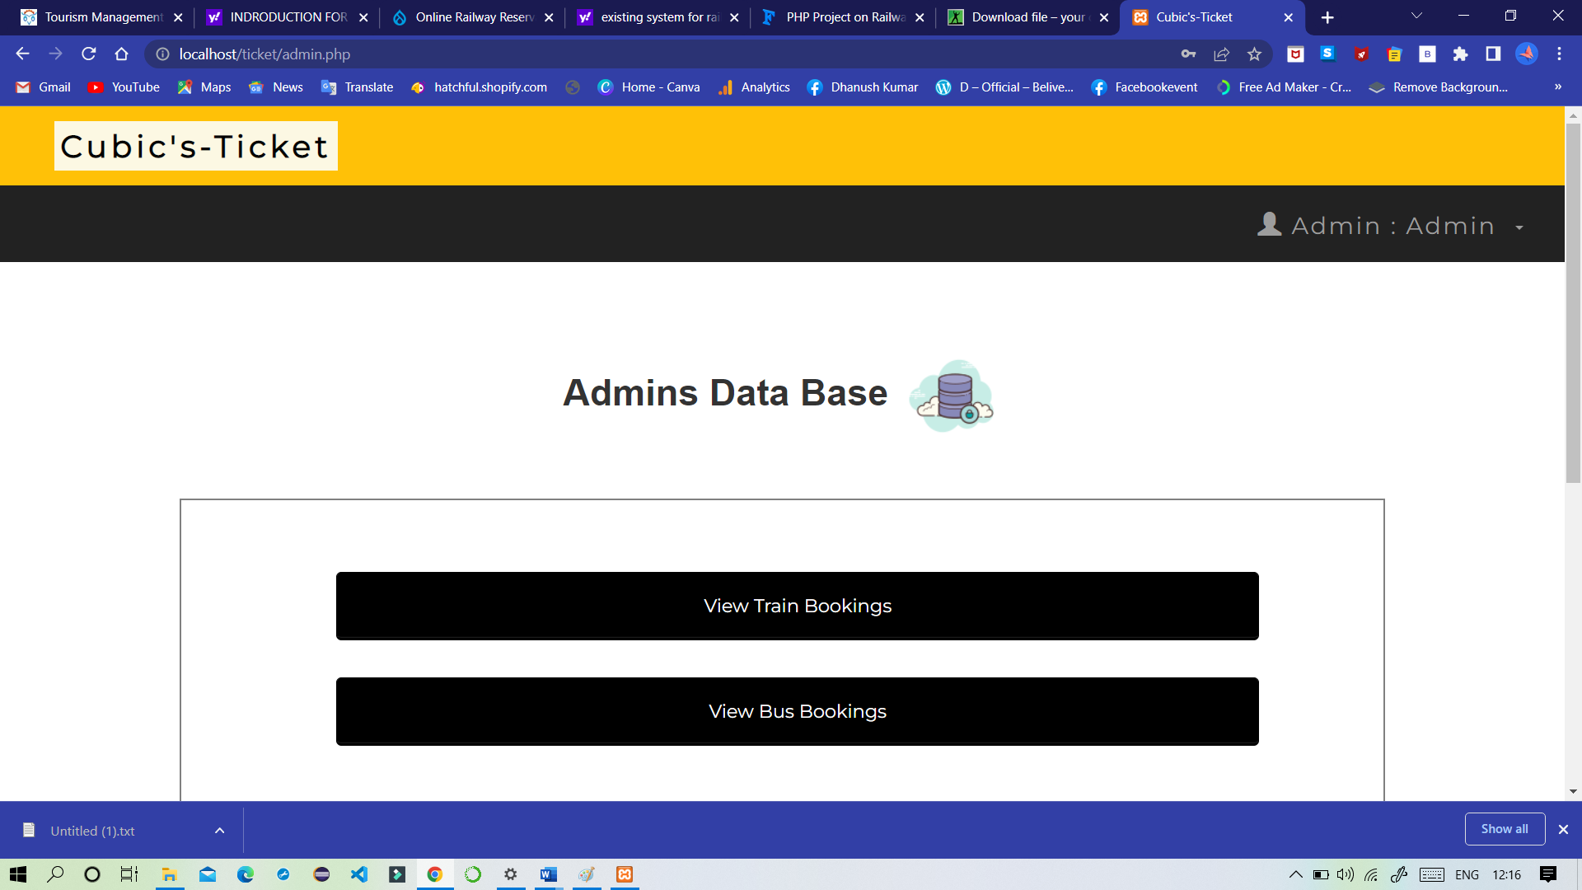

**8.SYSTEM SPECIFICATIONS:**

**8.1 Hardware Requirements:-**

* Pentium-IV(Processor).
* 256 MB Ram
* 512 KB Cache Memory
* Hard disk 10 GB
* Microsoft Compatible 101 or more Key Board

**8.2 Software Requirements: -**

* Operating System : Windows
* Web-Technology: PHP
* Front-End: HTML,CSS,JAVASCRIPT
* Back-End: MySQL
* Web Server: Apache SERVER.
* MOUSE : USB

**9.SYSTEM STUDY**

After doing the Tourism management system, study and analyzing all the existing are required functionalities of the system. The next task is to do the feasibility study for the project. All projects are feasible given unlimited resource and infinite time.

Feasibility study includes consideration of all the possible ways to provide a solution to the given problem.

* Economical feasibility: This very important aspect to be considered while developing a project. We decide the technology based on minimum possible cost factor.

* Technical feasibility: This included the study of function performance and constraints that may affect the ability to achieve an acceptable system.
* Operational feasibility: No doubt the propose system is fully GUI based that is very user friendly. A proper training has be conducted to let know the essence of the system to the users so that they feel comfortable with new system.

ECONOMIC FEASIBILITY

A system can be developed technically and that will be used if installed must still be a good investment for the organization. In the economical feasibility, the development cost in creating the system is evaluated against the ultimate benefit derived from the new systems. Financial benefits must equal or exceed the costs. The system is economically feasible. It does not require any additional hardware or software.

TECHNICAL FEASIBILITY

∙ The technical issue usually raised during the feasibility stage of the investigation includes the following:

∙ Does the necessary technology exist to do what is suggested?

∙ Do the proposed equipments have the technical capacity to hold the data required to use the new system?

∙ Will the proposed system provide adequate response to inquiries, regardless of the number or location of users?

∙ Can the system be upgraded if developed?

**10.SYSTEM DESIGN**

System design is the solution to the creation of a new system. This phase is composed of several system. This phase focuses on the detailed implementation of the feasible system. It translates design specification into performance specification. System design has two phases of development logical and physical design.

During logical design phase the analyst describes inputs (sources), outputs (destination), databases (data sources) and procedure (data flows) all in a format that meets the uses requirements. The analyst also specifies the user needs and at a level that virtually determines the information flow into and out of the system and the data resources. Here the logical design is done through data flow diagram and database design.

The physical design is followed by physical design or coding. Physical design procedure the working system by defining the specification, which tell the programmers exactly what the candidate system must do. The programmers write the necessary programs that accept input from the user, perform necessary processing on accepted data through call and produce the required report on a hard copy or display it on the screen.

As this website is static, we need not worry about the logical design. The only thing we should think about is the physical design on the website.

The design document that we will develop during this phase is the blueprint of the software. It describes how the solution to the customer problem is to be built. Since solution to complex problems isn’t usually found in the first try, iterations are most likely required. This is true for software design as well. For this reason, any design strategy, design method, or design language must be flexible and must easily accommodate changes due to iterations in the design. Any technique or design needs to support and guide the partitioning process in such a way that the resulting sub-problems are as independent as possible from each other and can be combined easily for the solution to the overall problem. Sub-problem independence and easy combination of their solutions reduces the complexity of the problem. This is the objective of the partitioning process. Partitioning or decomposition during design involves three types of decisions: - Define the boundaries along which to break; Determine into how money pieces to break.

PHYSICAL DESIGN

The systems objectives outlined during the feasibility study serve as the basis from which the work of system design is initiated. Much of the activities involved at this stage is of technical nature requiring a certain degree of experience in designing systems, sound knowledge of computer related technology and thorough understanding of computers available in the market and the various facilities provided by the vendors. Nevertheless, a system cannot be designed in isolation without the active involvement of the user. The user has a vital role to play at this stage too. As we know that data collected during feasibility study will be utilized systematically during the system design.

**System Design Considerations**

The system design process is not a step-by-step adherence of clear procedures and guidelines. Though, certain clear procedures and guidelines have emerged in recent days, but still much of design work depends on knowledge and experience of the designer. When designer starts working on system design, he will face different type of problems. Many of these will be due to constraints imposed by the user or limitations of the hardware and software available in the market. Sometimes, it is difficult to enumerate the complexity of the problems and solutions thereof since the variety of likely problems is so great and no solutions are exactly similar. However, following considerations should be kept in mind during the system-designing phase:

**a. Design Methodology:** Design Methodology is a way to transform the "art" of system analysis and design into an "engineering - type" discipline. It explains the relationship amongst various modules and programs with in the system. It standardizes the approach to analysis and design, simplifies design by segmentation, improves documentation and subsequent maintenance and enhancements. The following structured diagram can appropriately represent the relationship between various modules .

**b. Design Overview:** In analyzing the present system a great deal of information was collected during the investigation and feasibility phases through list of problems and requirements, interview reports, questionnaires, onsite observations, manuals and determining potential solutions. It is important to record this information in an unambiguous, concise manner which will be clear and accessible to others, and which can be used by other analysts and designers involved in developing the system. Structured techniques help us to record the information in this way, using diagrams and minimum amount of the text.

**c. Process Modeling:** System design goes through two phases of development: logical and physical. Logical implementation represented by Data Flow Diagram shows the logical flow of a system and defines the boundaries of the system it describes the input (source), outputs 17 (destinations), data bases (data stores), and procedures (data flows) - all in the format that meets the user's requirements.

4.2 DATA FLOW DIAGRAM

Data flow diagrams are the most commonly used way of documenting the processing of the candidate system. As their name suggest they are a pictorial way of representing the flow of data into, around, and out of the system.

**• External entities** - represents the sources of the data that enter the system or the recipients of the system that leave the system. for example - passenger is the usual receiver of information and supplier of data during form filling.

**• Data stores** - represent the stores of the data within the system example: computer files, databases or in the manual system files, etc. data stores can not be linked directly by data flows either to each other or to external entities without an intervening process to transform them.

**• Processes** - represent activities in which data is manipulated by being stored or retrieved or transformed in some way. Process names are generally unambiguous and convey as much meaning as possible without being too long. Example: verify data, acquired time schedule etc.

**10.1. USE CASE DIAGRAM**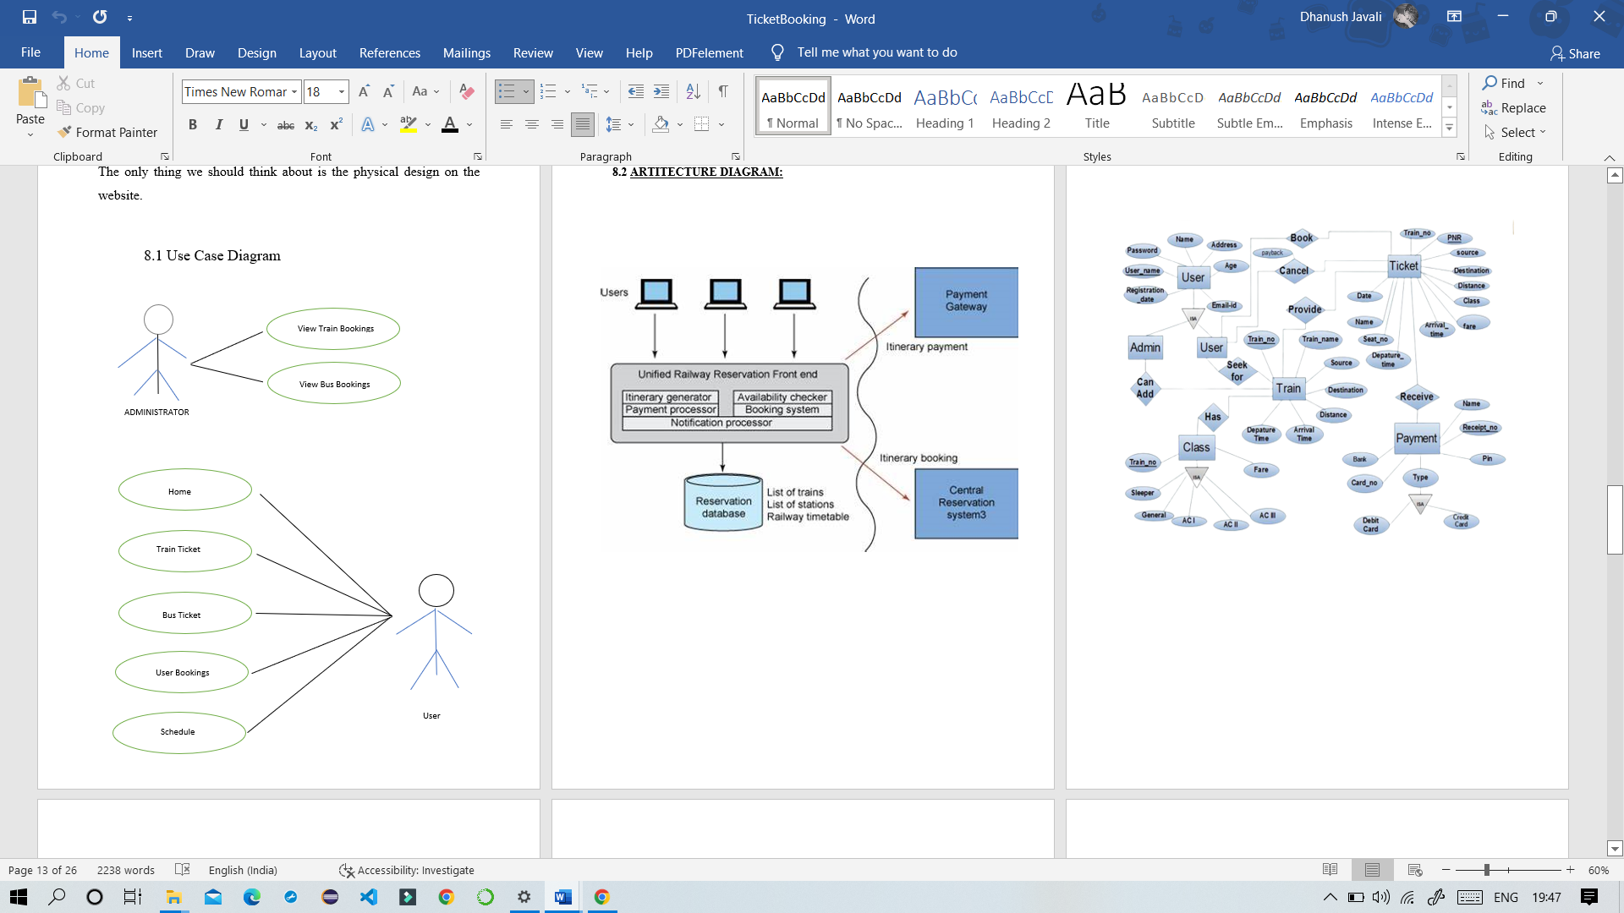

**10.2 ARTITECTURE DIAGRAM:**

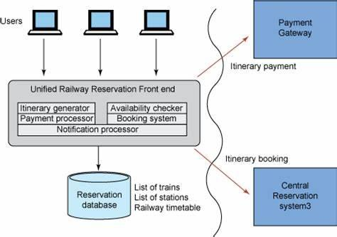

**10.3 ENTITY RELATIONSHIP DIAGRAM OF TICKET BOOKING SYSTEM**

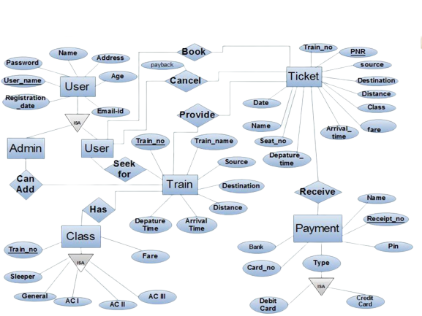

**10.4 DFD DIAGRAM**

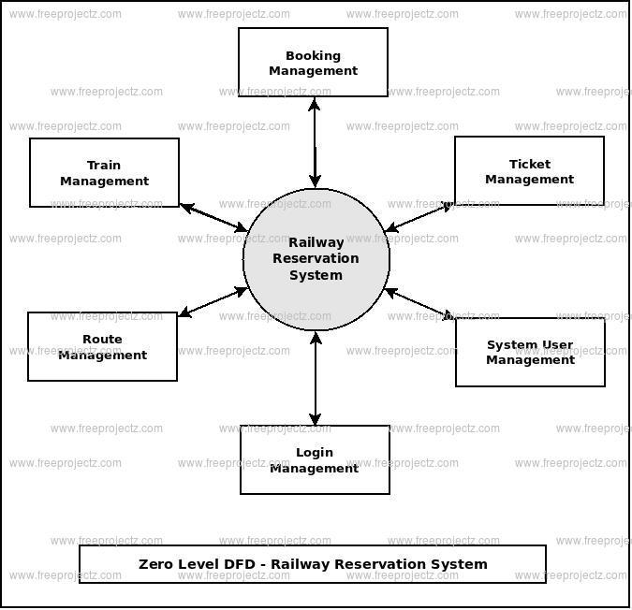

**11.SOURCE CODE**

**Index Page:**

<?php

include 'homehead.php';

?>

<style >

.container{

border-spacing: 10px;

font-family: Montserrat, sans-serif;

font-size: 18px !important;

border: 2px solid grey;

margin-top: 50px;

margin-bottom: 200px;

padding-top: 50px;

padding-right: 120px;

padding-bottom: 50px;

padding-left: 150px;

align-content: center;

}

</style>

<html>

<head>

<link rel='stylesheet' href='index.css'>

<br><br>

<h1 text-transform: capitalize;><center><b><img src="https://img.icons8.com/clouds/90/000000/add-bookmark.png"/> Welcome To Cubic's-TICKET Booking Portal <img src="https://img.icons8.com/clouds/90/000000/add-bookmark.png"/></center></b></h1>

<div class="container">

<td><a href='book.php'><button style="background-color: black ; border-color:black " ><img src="https://img.icons8.com/nolan/54/train.png"/>&nbsp&nbspBook Train Tickets </button></a></td>

</tr>

<br> <br>

<tr>

<td><a href='bookbus.php'><button style="background-color: black ; border-color:black "><img src="https://img.icons8.com/nolan/54/bus.png"/>&nbsp&nbspBook Bus Tickets</button></a></td></td>

</tr>

</table>

</tr>

</div>

<?php include 'footer.php';

?>

</html>

**Admin Page:**

<?php

include 'connect.php' ;

session_start();

if ($_SESSION['log'] == '')

{

header("location:adminindex.php");

}

include 'adminheader.php';

?>

<br>

<br>

<style >

.container{

border-spacing: 10px;

font-family: Montserrat, sans-serif;

font-size: 18px !important;

border: 2px solid grey;

margin-top: 50px;

margin-bottom: 200px;

padding-top: 50px;

padding-right: 120px;

padding-bottom: 50px;

padding-left: 150px;

align-content: center;

}

</style>

<html>

<head>

<link rel='stylesheet' href='index.css'>

<br><br>

<h1><center><b> Admins Data Base <img src="https://img.icons8.com/clouds/100/000000/lock-database-.png"/> </center></b></h1>

<div class="container">

<td><a href='admintraindb.php'><button style="background-color: black ; border-color:black " >View Train Bookings </button></a></td>

</tr>

<br> <br>

<tr>

<td><a href='adminbusdb.php'><button style="background-color: black ; border-color:black ">View Bus Bookings</button></a></td></td>

</tr>

</table>

</tr>

</div>

<?php include 'footer.php';

?>

</html>

**Train Booking:**

<?php

include 'connect.php' ;

session_start();

if ($_SESSION['log'] == '')

{

header("location:sindex.php");

}

include 'header.php';

?>

<div>

</div>

<style>

table#database_table {

font-size:16px;

font-family: "Trebuchet MS", Arial, Helvetica, sans-serif;

border-collapse: collapse;

border-spacing: 0;

}

#database_table td, #database_table th {

border: 1px solid #ddd;

text-align: left;

padding: 8px;

}

#database_table tr:nth-child(even){background-color: #f2f2f2}

#database_table th {

padding-top: 11px;

padding-bottom: 11px;

background-color: black;

color: white;

}

</style>

<head>

<title>Cubic's-TICKET DATABASE</title>

</head>

<body >

<h2><center><b><img src="https://img.icons8.com/nolan/64/database.png"/> USER'S TRAIN BOOKINGS <img src="https://img.icons8.com/ultraviolet/60/000000/train.png"/></center></b></h2>

<div class="container">

<br />

<table id="database_table" class="table table-striped table-bordered">

<thead>

<tr>

<th>Date & Time </th>

<th>Booking ID </th>

<th>Name</th>

<th>Source</th>

<th>Destination</th>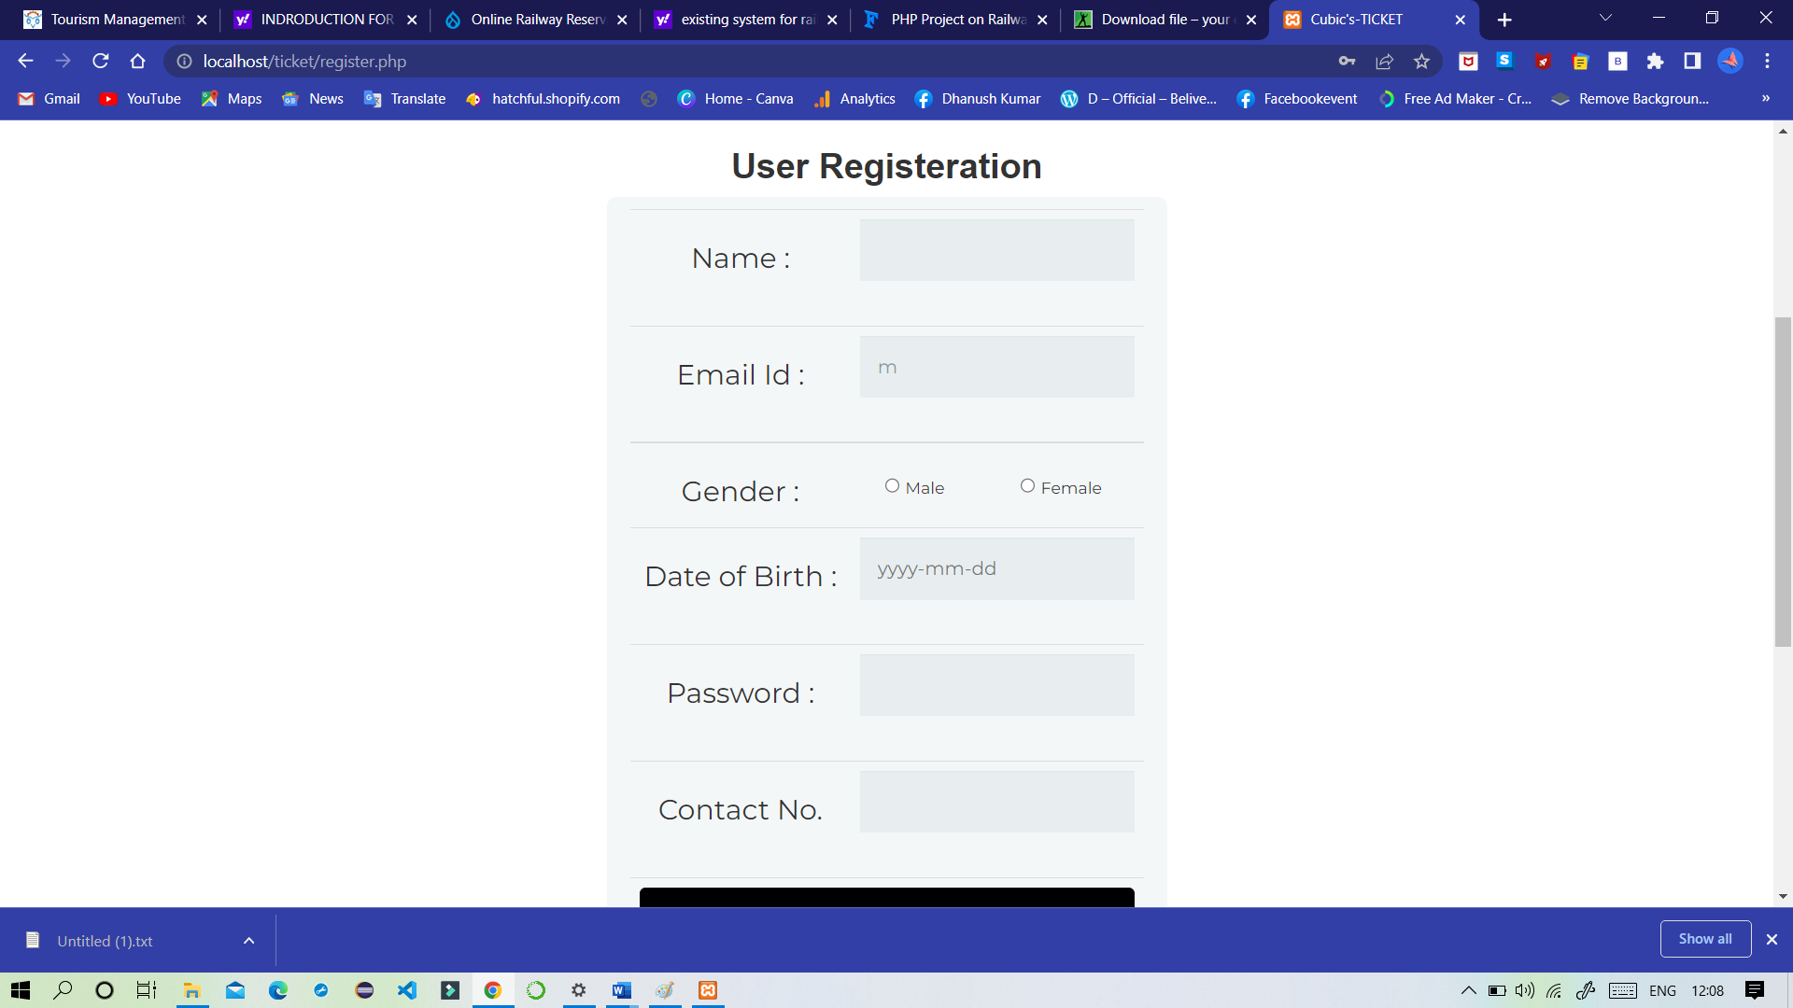

<th>Class</th>

<th>Type</th>

<th>Amount Paid</th>

<th>Download</th>

</tr>

</thead>

<tbody>

<?php

$sql_transactions="SELECT * FROM `transactions` WHERE `email`='".$_SESSION['email']."' " ;

$result = $connect->query($sql_transactions);

while($row = $result->fetch_assoc()){

echo'<tr class="class="table table-striped table-bordered"">

<td>'.$row["Date"].'</td>

<td>'.$row["T_No."].'</td>

<td>'.$row["Name"].'</td>

<td>'.$row["source"].'</td>

<td>'.$row["dest"].'</td>

<td>'.$row["Class"].'</td>

<td>'.$row["Type"].'</td>

<td>₹&nbsp&nbsp'.$row["Amt"].'</td>

<td><a href="print.php?pid='.$row["T_No."].' " target="_blank">Click Here</a></td>

';

}

?>

</tbody>

</table>

</div>

<script>

$(document).ready(function() {

$('#database_table').DataTable( {

"order": [[ 1, "desc" ]]

} );

} );

</script>

**Bus Booking:**

<?php

include 'connect.php' ;

session_start();

if ($_SESSION['log'] == '')

{

header("location:sindex.php");

}

include 'header.php';

?>

<style>

.container{

border-spacing: 10px;

font-family: Montserrat, sans-serif;

font-size: 18px !important;

border: 2px solid grey;

margin-top: 30px;

margin-bottom: 50px;

padding-top: 50px;

padding-right: 50px;

padding-bottom: 50px;

padding-left: 150px;

align-content: center;

}

.button {

padding: 15px 32px;

align-content: left;

color: white;

background-color:black;

}

#number {

overflow: hidden;

width: 600px;

}

input[type=number]{

width: 250px;

}

</style>

</script>

</head>

<body>

<h1><center><b><img src="https://img.icons8.com/bubbles/80/000000/bus.png"/>Bus Ticket Booking &nbsp <img src="https://img.icons8.com/officel/54/000000/road.png"/></center></b></h1>

<form method='post' action ='busaction.php' align='center'>

<div class="container">

<section id="form" class="formborder">

<div class="container2">

<form>

<div class="form-row row justify-content-around" name="source">

&nbsp

<div class="form-group col-md-5" name="source">

<label for="inputEmail4">SOURCE BUS-STOP :</label>

<select id="inputState" class="form-control" name="source">

<option>UBDT College</option>

<option>Stadium</option>

<option>High Court</option>

<option>Myjestic</option>

<option>Dental College</option>

<option>Union Park</option>

<option>Zoo Stop</option>

<option>SS Mall</option>

<option>Tin Factory</option>

<option>Ganapati Temple</option>

<option>KSRTC Stop</option>

<option>Airport</option>

<option>Railway Station</option>

<option>Vaibhav Resto</option>

<option>Desi Street</option>

<option>Bull Temple</option>

<option>Cinema Max</option>

<option>Udaya Hospital</option>

<option>Boys Hostel Road</option>

</select>

<!-- <input type="email" class="form-control" id="inputEmail4" placeholder="FROM">--></div>

<div class="form-group col-md-5" name="dest">

<label for="inputPassword4">

FINAL BUS-STOP :</label>

<select id="inputState" class="form-control" name="dest">

<option>UBDT College</option>

<option>Stadium</option>

<option>High Court</option>

<option>Myjestic</option>

<option>Dental College</option>

<option>Union Park</option>

<option>Zoo Stop</option>

<option>SS Mall</option>

<option>Tin Factory</option>

<option>Ganapati Temple</option>

<option>KSRTC Stop</option>

<option>Airport</option>

<option>Railway Station</option>

<option>Vaibhav Resto</option>

<option>Desi Street</option>

<option>Bull Temple</option>

<option>Cinema Max</option>

<option>Udaya Hospital</option>

<option>Boys Hostel Road</option>

</select>

<!--<input type="password" class="form-control" id="inputPassword4" placeholder="TO">-->

</div>

<div class="form-row row justify-content-aroundd">

<div class="form-group col-md-16" >

<center><label for="inputState" ><h8>NO OF PASSENGERS :</h8></label></center>

<center> <input type="number" name="number" required min="1" max="5" ></center>

</div>

<br>

<div>

<button type="submit" class="button" name="login_submit" >Proceed</button>

</div></form></div></section></div></body><?php include 'footer.php';?> </html>

**Database Connecting Page:**

<?php

$hostname = 'localhost';

$username = 'root';

$password='';

$dbname = 'train';

$connect = mysqli_connect($hostname , $username , $password ,$dbname) or die("Error Connecting");

?>

**Table Structure of Admin :**

Table structure for table `admindatabase`

--

CREATE TABLE `admindatabase` (

  `UserID` int(10) NOT NULL,

  `Name` varchar(50) NOT NULL,

  `Email` varchar(70) NOT NULL,

  `Gender` varchar(10) NOT NULL,

  `password` varchar(50) NOT NULL,

  `DoB` date NOT NULL,

  `Joined_on` timestamp NOT NULL DEFAULT current_timestamp()

) ENGINE=InnoDB DEFAULT CHARSET=latin1;

--

-- Dumping data for table `admindatabase`

--

INSERT INTO `admindatabase` (`UserID`, `Name`, `Email`, `Gender`, `password`, `DoB`, `Joined_on`) VALUES

(1, 'Admin', 'admin@gmail.com', 'M', '1234567', '2000-10-17', '2021-08-14 18:30:00');

**12. TESTING**

TESTING PHASE

In a software development project, errors can be injected at any stage during development. There are different techniques for detecting and eliminating errors that originate in that phase. However, no technique is perfect, and it is expected that some of the errors of the earlier phases will finally manifest themselves in the code. This is particularly true because in the earlier phases and most of the verification techniques are manual because no executable code exists. Ultimately, these remaining errors will be reflected in the code. Hence, the code developed during the coding activity is likely to have some requirement errors and design errors, in addition to errors introduced during the coding activity. Behavior can be observed, testing is the phase where the errors remaining from all the previous phases must be detected. Hence, testing performs a very critical role for quality assurance and for ensuring the reliability of software.

During testing, the program to be tested is executed with a set of test cases, and the output of the program for the test cases is evaluated to determine if the program is performing as expected. Due to its approach, dynamic testing can only ascertain the presence of errors in the program; the exact nature of the errors is not usually decided by testing. Testing forms the first step in determining the errors in a program. Clearly, the success of testing in revealing errors in programs depends critically on the test cases.

Testing a large system is a very complex activity, and like any complex activity it has to be broken into smaller activities. Due to this, for a project, incremental testing is generally performed, in which components and subsystems of the system are tested separately before integrating them to form the system for system testing. This form of testing, though necessary to ensure quality for a large system, introduces new issues of how to select components for testing and how to combine them to form subsystems and systems.

**12.1 LEVELS OF TESTING**

The different types of testing are as follows: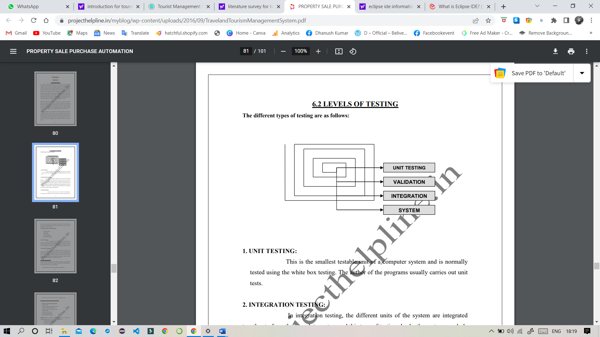

**1. UNIT TESTING:**

This is the smallest testable unit of a computer system and is normally tested using the white box testing. The author of the programs usually carries out unit tests.

**2. INTEGRATION TESTING:**

In integration testing, the different units of the system are integrated together to form the complete system and this type of testing checks the system as whole to ensure that it is doing what is supposed to do. The testing of an integrated system can be carried out top-down, bottom-up, or big-bang. In this type of testing, some parts will be tested with white box testing and some with black box testing techniques. This type of testing plays very important role in increasing the systems productivity. We have checked our system by using the integration testing techniques.

**3. SYSTEM TESTING:**

A part from testing the system to validate the functionality of software against the requirements, it is also necessary to test the non-functional aspect of the system. Some examples of non-functional tools include tests to check performance, data security, usability/user friendliness, volume, load/stress that we have used in our project to test the various modules.

System testing consists of the following steps:

1. Program(s) testing.

2. String testing.

3. System testing.

4. System documentation.

5. User acceptance testing.

**4. FIELD TESTING:**

This is a special type of testing that may be very important in some projects. Here the system is tested in the actual operational surroundings. The interfaces with other systems and the real world are checked. This type of testing is very rarely used. So far our project is concerned; we haven't tested our project using the field testing.

**5. ACCEPTANCE TESTING:**

After the developer has completed all rounds of testing and he is satisfied with the system, then the user takes over and re-tests the system from his point of view to judge whether it is acceptable according to some previously identified criteria. This is almost always a tricky situation in the project because of the inherent conflict between the developer and the user. In this project, it is the job of the bookstores to check the system that whether the made system fulfills the goals or not.

**WHY SYSTEM TESTING?**

Testing is vital to the success of the system. System testing makes a logical assumption that if all the parts of the system are correct, the goal will be successfully achieved. Inadequate testing results in two types of problems:

1. The time lag between the cause and the appearance of the problem.

2. The effect of system errors on the files and records within the system.

Testing is a set activity that can be planned and conducted systematically. Testing begins at the module level and work towards the integration of entire computers based system. Nothing is complete without testing, as it is vital success of the system.

* Testing objectives

There are several rules that can serve as testing objectives, they are

1. Testing is the process of executing a program with the intend of finding an error.
2. A good test case is one that has high probability of finding an undiscovered error.
3. A successful test is one that uncovers an undiscovered error.

There are two ways to test the program:

1. For correctness
2. For implementation efficiency

Testing for correctness, it is supposed to verify that a program does exactly what it was designed to do. This is much difficult then it may at first appear, especially for large programs.

Tested for implementation efficiency and an attempt to find ways to checks correctness of web pages. Faster execution and use less storage.

**13.INPUT / OUTPUT SCREENS:**

**PASTE HERE YOUR PROJECT INPUT AND OUTPUT SCREENS**

**13.CONCLUSION AND FUTURE ENHANCEMENT:**

* We can provide SMS based alerts and email notifications for bookings.
* The wallet can be developed to handle discounts on the points basis. It can also be used to provide referral code concept for referring friends.
* Chat feature can be included in the application to chat with customer care.
* We can come with a feature that will allow the customer to save favourite routes and provide discounts for same.
* Introduce coupon management for providing coupons which customers can use to avail discounts.

Train and Bus Booking System php project report The main outcome and achievement of this project is to achieve all the objectives. Therefore, Train Ticket is developed as php based system to ease the process of buying the bus ticket in more efficiently and quickly and develop a website for staff and administrator to manage the bus booking system.

Some ideas have been suggested for future improvement of TrainTicket. Train Ticket can be enhanced into a better quality to benefits its users. The suggestion for future improvement on Train Ticket are integraton with other online banking system to make the payment gateway more flexible so that user can be more convenient. Other suggestion is Train Ticket should be enhanced to iOs platform since the number of user is rapidly increasing.

Taking into account all the mentioned details, we can conclude that the Train Ticket Booking & Management System Project is an inevitable part of the lifecycle of the Travelling. It automates numerous daily operations and enables smooth interactions of the users. Developing the Train management system software is a great opportunity to create distinct, efficient, and fast delivering ticket Bookings. Implementation of Train management system project helps to store all kinds of records, provide coordination and user communication, implement policies.

**14.REFERENCES**

1. <https://www.phptpoint.com>
2. <https://code-projects.org>
3. <https://phpgurukul.com>
4. [www.youtube.com](http://www.youtube.com)
5. PHP MySQL Website Programming: Problem - Design – Solution byChrisLea, Mike Buzzard, Dilip Thomas , Jessey White-Cinis
6. Beginning PHP5, Apache, and MySQL Web Development (Programmer to Programmer) by Elizabeth Naramore
7. MySQL/PHP Database Applications, 2nd Edition by Brad Bulger
8. How to Do Everything with PHP and MySQL by Vikram Vaswani